**The Astwell Benefice**

*Helmdon with Stuchbury and Radstone, and Syresham with Whitfield,Lois Weedon with Weston and Plumpton and Wappenham*

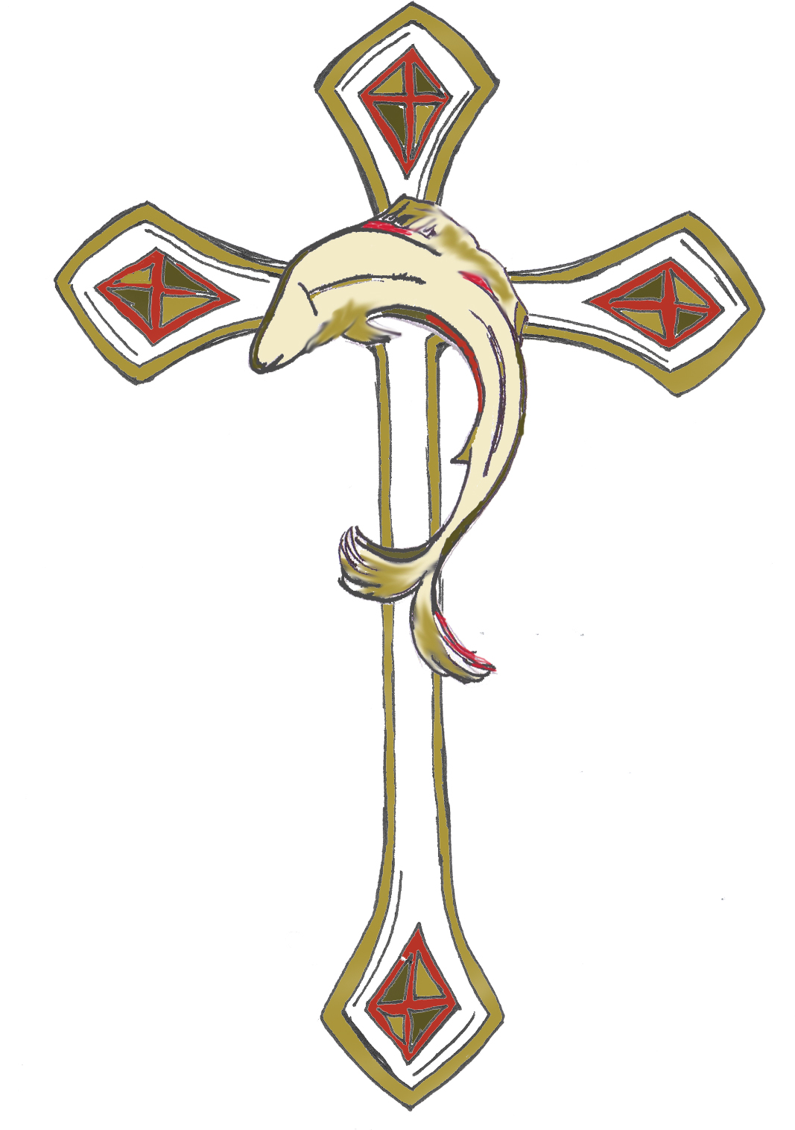

Finance Committee – Minutes 25/11/24

**Present:** Alice Palmer, Clive Johnson, Brenda Faragher, Clare Bonner, Bill Elkington, Paul Stothard & Hugh White

**Apologies** : Philip Thompson, Ann Netten

The meeting opened with a prayer.

**Minutes**

We agreed the minutes from 16/6/24

**Matters Arising**

* None

**Parish & Benefice Accounts**

Benefice

The Benefice has £4702 in hand at the moment with a projected spend of £1400 over the next month. The meeting agreed that £150 charitable given should be sent to the DEC fund.

AP talked through the benefice budget. Based on 2024 expenditure the mileage allowance and printing costs has been reduced. This leaves a benefice budget of £8560. The Diocesan share would be £5195. Projected income is £5000 from fees and £3500 from reserves. The projected fundraising from Rogation and the Social and Fundraising committee was deemed to be an over estimate. This means most of the £5195 will have to be reallocated to parishes next year. It was agreed that the Wardens would meet on January 13th, 10am at Vine Cottage to discuss how we allocate the Parish Share for 2025. AP to organise. Also that HW would do some teaching on giving over the next year.

Action HW/AP

On this point CJ acknowledged that at the current time, the intention was that all 100% of the proceeds from the Astwell Festival activities would be donated to charity. However, CJ added that given that this means a large drop in direct income to the Benefice and moreover, it is then likely fall to the parishes to fill the funding gap through additional share allocation (on top of the known year on year increase), is there not a strong case for a rethink on the 100% charity allocation. Could consideration be given that the proceeds from the Astwell Festival be split say 80/20 (charity/benefice) or more other equitable basis, so the Benefice gets at least some of the income. This would soften any further increase to Parish Share allocation for each parish. PS said that this would need to be put to the Fundraising/Festival Committee and will be discussed at the Wardens meeting.

Action AP

There is £154 held for “an emergency” for someone who made a donation. AP to ask if this could be used for the Parish Share.

Action AP

*NB – this has now been agreed.*

Helmdon

Helmdon’s Regular Giving has decreased due to some the deaths of some generous parishioners. They expect to pay £23,230 towards the Parish Share by the end of December depending on the success of their Christmas Fair. This represents 97% of the total a shortfall of £755. Radstone have been unable to contribute this year due to the cost of their Quinquennial.

Helmdon’s insurance costs appear to be on a par with other churches despite paying for the Radstone insurance.

They held and open gardens this year instead of the summer fete. They will do the same in 2025 but are considering what to do about timing a raffle so that it doesn’t clash with the Astwell Festival raffle.

Helmdon need to keep money in reserve to pay for oil in January.

Lois

The Lois Weedon accounts are in exceptionally good order. They will be able to pay their full Parish Share this year for the first time in many years. Fundraising through the coffee mornings and an afternoon garden party, an evening cheese & wine party and the Harvest supper evening has gone well.

Generous donations have been received to cover the cost of work on the chancel window. They have just had a Quinquennial report which requires further work to be done in the church.

CJ has opened a savings account to earn a little interest on monies being stored towards fabric costs.

Wappenham

Wappenham are also in a good financial position at present. Once the final standing orders have been received they will have paid their full Parish Share. Regular giving has increased. Fundraising has been more successful than last year and they have £12709 allocated to upcoming fabric works.

Syresham

In Syresham, regular giving has increased thanks to two new generous contributors. They are awaiting some further giftaid. They have received grants and donations towards work on the church steeple, which starts in the next week. They still have their Christmas Fair to come for Fundraising. It is hoped that this will raise enough money so that they can top up their Parish Share by £3,400 taking them to £16,300 93% of the total – better than ever before.

Whitfield

Whitfield’s regular giving has increased this year and ST & CB have done excellent work on fundraising. The Friends of St John have paid for the building part of their insurance. There is some concern that they may be using up all their reserves. CB is chasing the gift aid claim for this year, which should amount to about £400.

While not able to meet their full share, Whitfield aim to top up their contribution by at least £1,700. This s higher than last year - 83% of the total.

There was some discussion on whether we could get cheaper insurance as a joint benefice. AP explained that she had sent our constitution to the insurers and they had stated that we are not able to get the discount as each parish is responsible for their own buildings.

**PARISH SHARE**

The projected extra contributions to the parish share would bring us to a total of £70,719.19 paid to the benefice. This is 99% of the total. An excellent result - thanks to some generous new regular givers and a lot of hard work. The meeting decided that we would review the final total at the end of December, once Christmas Fairs and other monies have been finalised. If we still have a shortfall parishes will look at meeting remaining shortfall – we hope this will be less than £1000 shared between four parishes.

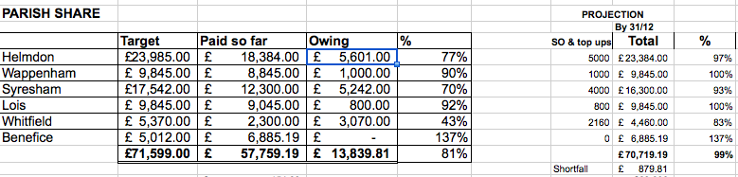

**AOB none**

**NEXT MEETING** : Monday 20th January 11am @ Vine Cottage.

BENEFICE BUDGET

