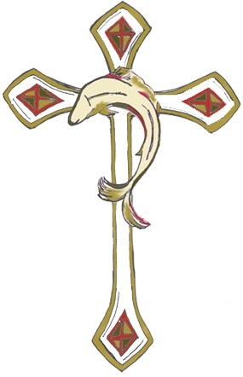
The Astwell Benefice
WEDDING APPLICATION FORM
For the Church of:

…………………………………..…………………

Date:……………………………..Time:………………

St Mary Magdalene Helmdon with Stuchbury and St Lawrence Radstone, St Mary and St Peter Lois Weedon with Weston and Plumpton, St James the Great Syresham with St John the Evangelist Whitfield, and St Mary the Virgin Wappenham

BANNS: 1st Reading: …………………… 2nd Reading: …………………….. 3rd Reading: ………………………
Groom’s details:  Full name:  Date of Birth: | Condition: (circle which applies)  Single  Widower  Previous Marriage Dissolved  Previous Marriages  Dissolved  Survivor of a  Civil Partnership  Civil Partnership  Dissolved | Profession or occupation: | Current Address:  Post Code:  Phone and email: | Your Parish Church:  (if this is not where you are being married you will need the banns read here as well) | Full names & occupations of Groom’s parents/step-parents/adoptive parents (pls also circle if they are retired and/or deceased):  1 .  Retired/Deceased  2.  Retired/Deceased  3.  Retired/Deceased  4.  Retired/Deceased

Bride’s details  Full name:  Date of Birth: | Condition: (circle which applies)  Single  Widower  Previous Marriage Dissolved  Previous Marriages  Dissolved  Survivor of a  Civil Partnership  Civil Partnership  Dissolved | Profession or occupation: | Current Address:  Post Code:  Phone and email: | Your Parish Church:  (if this is not where you are being married you will need the banns read here as well) | Full names & occupations of Bride’s parents/step-parents/adoptive parents (pls also circle if they are retired and/or deceased):  1 .  Retired/Deceased  2.  Retired/Deceased  3.  Retired/Deceased  4.  Retired/Deceased

Please attach the following: a photocopy of the picture pages of both passports, Banns Certificate (if applicable), a copy of Decree Absolute (if applicable)

WEDDING FEES

The statutory fee for a wedding in our Benefice from 4th May 2021 is £495 (this fee changes annually). This includes the wedding service, church lighting, and the cost of reading of the banns (a legal requirement). It does not include the cost of preparing and cleaning the church before and after the wedding under Covid-secure regulations (please discuss these requirements with the relevant churchwarden), church heating, or the optional extras below. The cost of a Banns Certificate is £15, should you require this.
If you are being married by special licence (ie. not after banns), the fee for your wedding will be £464.

Optional extra costs payable in cash are (please bring envelopes marked for each recipient to the dress rehearsal):

Organist: £90
Bells: £175
Choir: £100
Verger: usually £25 (or as agreed with Parish)
Flowers: on request

The cost of the wedding itself should be paid in full by a month before the big day. We are happy to accept installments up to a month before. No deposit is required. Cheques should be made payable to: “The Astwell Benefice”, or you can make a direct payment to:
Account Number: 50206183
Sort Code: 09-01-55 (Santander) and please use your names as a reference.

Would you like:

Bells yes /no

Organist yes/no

Flowers yes/no

