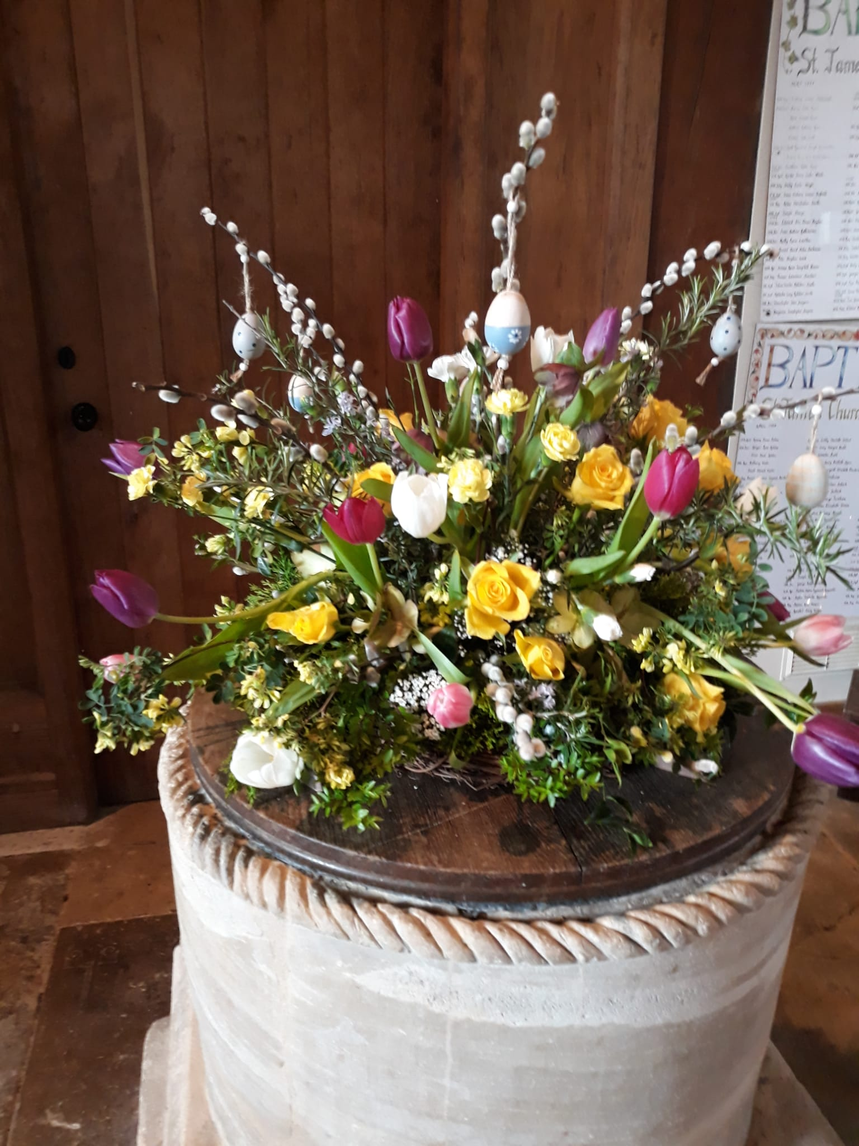
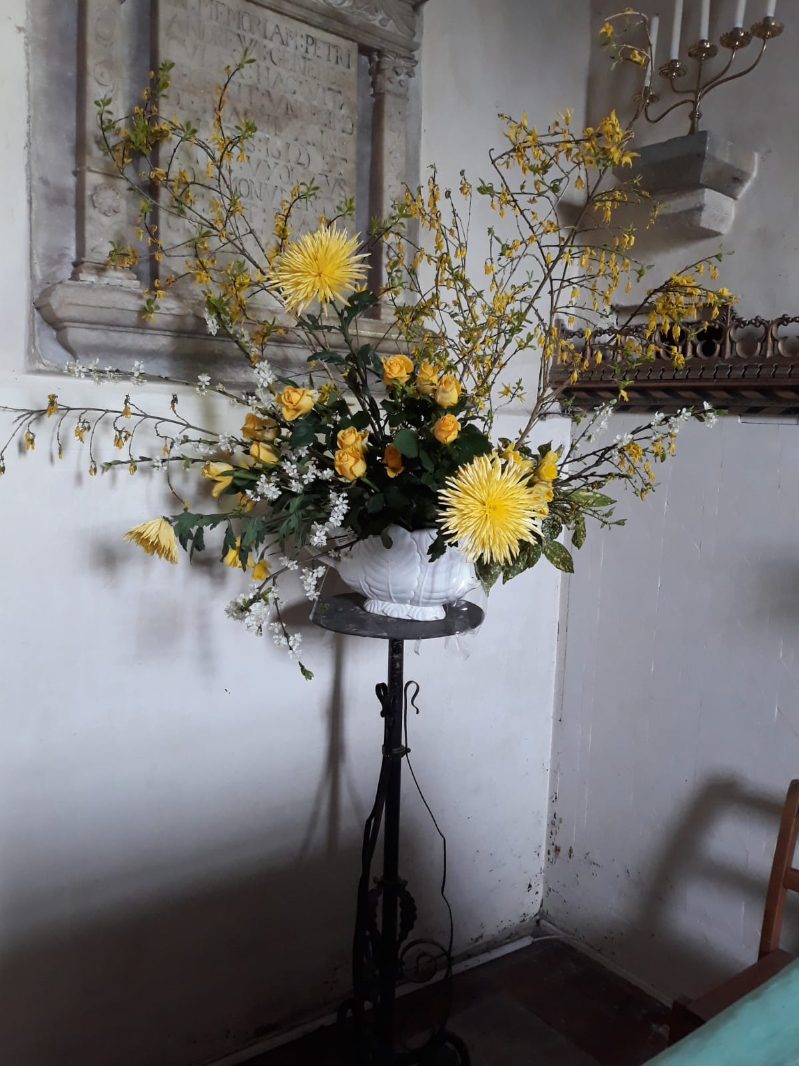
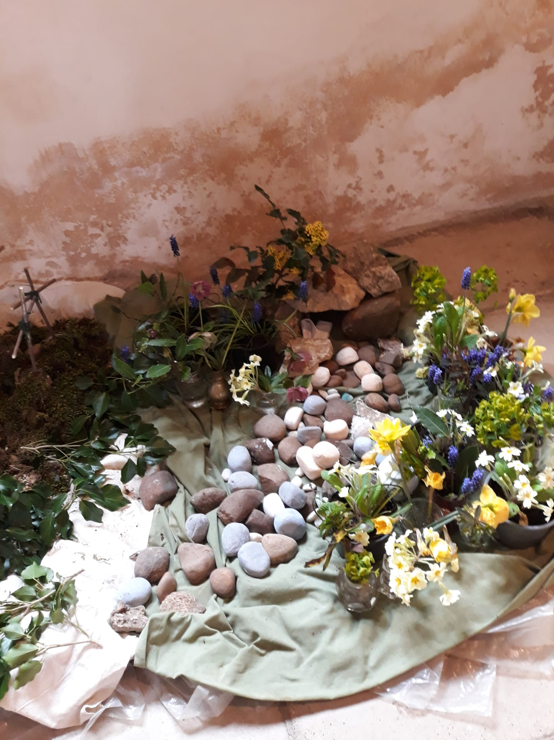
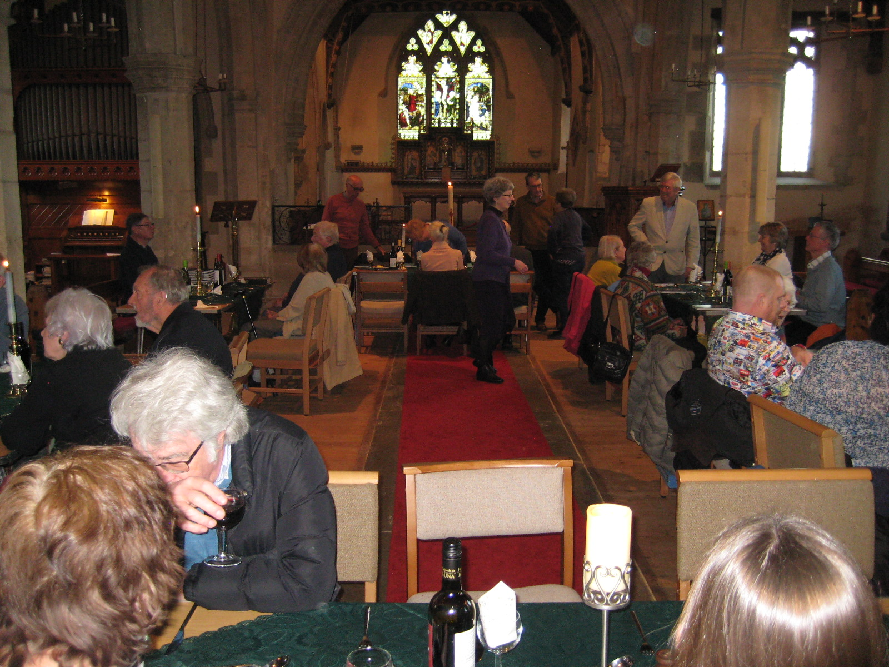

News from the church

From the SUBLIME to the RIDICULOUS

The sublime is our Easter Celebrations, ranging from a fun filled Messy church; to the fellowship of a meal and communion shared together on Maundy Thursday; the moving re-reading of the death of Jesus ending in deep silence on Good Friday and culminating in a joyful service on Easter Sunday – which, of course, included the Easter Hunt & chocolate.

We are now looking forward to a UNITED SERVICE to mark the CORONATION of King Charles III. FREE CONTINENTAL BREAKFAST will be served from 9:15 in church, followed by a service of readings and prayers for the King and Kingdom. We hope that many individuals and organisations in the village will want to be represented at this event.

In June we anticipate the Benefice Barn dance and on July 1st we look forward to the return of the popular choir Note-Ability to give a concert in church.
Together with our trusty band of volunteers, we have been working on the 158 items listed in our architects five yearly inspection of the church and churchyard. We drew down money from the Payne Trust Fund to pay for work that needs to be done by professionals, thinking everything was well under control. The RIDICULOUS moment came when we realised that a sentence “the steeple shingles should be inspected”, actually meant all the shingles on the church steeple need to be replaced – and also allow for rotten timbers beneath and the cost will be over £60,000. I feel I can ask the trustees to draw down a further £20,000, we have £5000 to use in our bank account and I am asking the Friends of the Church if we could use the 200-club money for the steeple this year. We can get half way there. After that you may find me out and about with my metaphorical begging bowl applying to charities and anyone willing to save our steeple. All help welcomed however small.

Contact me if you would like to know more about any of the above.

