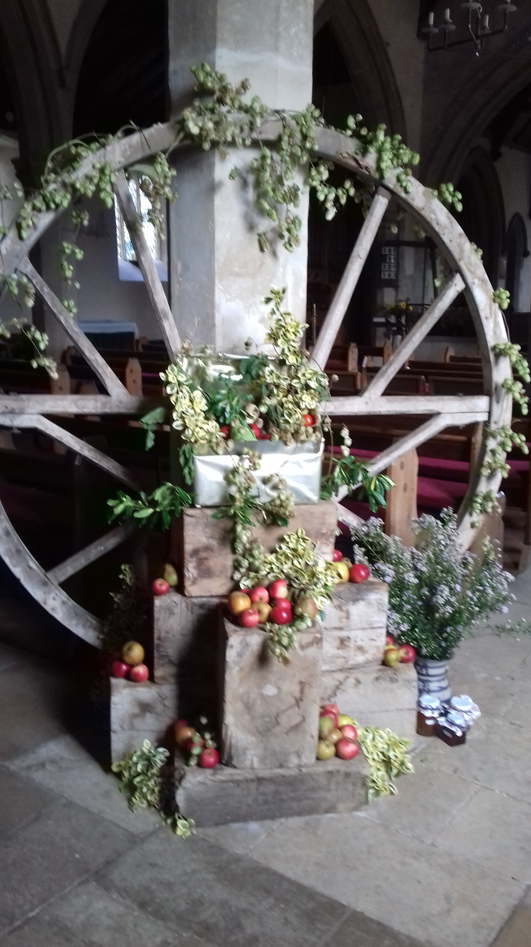
News from the Church

At the end of September we gave thanks for all the good gifts we have whilst also reflecting on our need to reach out to others with generosity. The school brought gifts for the food bank to their service and the congregation gave generously to a farming charity and the DEC disasters fund.

Our Helpers The Churchyard Working Party have finished work for the year tackling a range of jobs from ivy clearing to painting ironwork. A huge thank you to all who contributed. I started making a list of all the folk who help us in various ways and have got to over seventy so far thank you all.
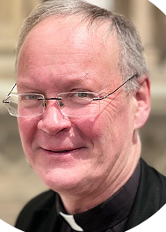
New Rector We are looking forward to welcoming Revd Dr Hugh White as our Rector. He starts officially on December 7th and we hope he will manage to visit all the parishes over the Christmas period. We will hold a Syresham welcome party at some time in the New Year to give everyone a chance to meet and greet him. As I write Hugh is working as part of a team in Witney, with particular responsibility for Minster Lovell Parish where he plays cricket for the village. He has a role as Diocese’s Link Officer for its link with Växjö Diocese in Sweden. Prior to ordination he was a university lecturer.

A bit of a cliff hanger….. The deadline for this article is the 31st of October – this is also the deadline for final tenders to complete the work needed on the church steeple – I will, no doubt, be letting you know of the outcome soon.

An angled mirror? I do try to follow St James’ teaching to “count it all joy when you face various kinds of trials, knowing that testing of your faith develops perseverance’ –it was quite a challenge when we learned that bats had moved back into our belfry, causing more costs for the project. However, only thirty seconds listening to the world news rebalances the perspective and reminds us of the need to: count our blessings and be an angled mirror to reflect God’s love into the world and reflect the world’s joys and tribulations back to God.

With this in mind we look forward to a season of remembering, All Souls, Wars and the Light coming into the darkness of the world. Here are some dates to look out for.

November 1st 5:30 - All Souls service to remember our loved ones.
November 4th - Friends of St James Autumn walk & soup lunch.
November 10th-12th – Friends’ exhibition of poppies and war memorabilia
November 12th – Joint Remembrance service at the Stone.
December 2nd - Christmas Fair in Church
December 17th – Joint Carols by Candlelight in church
December 24th – Christingle – the quiet one at 3 – the traditional version 4:30
Christmas Day -10:30 – Family service with carols

