The Astwell Benefice
Helmdon with Stuchbury and Radstone, and Syresham with Whitfield,
Lois Weedon with Weston and Plumpton and Wappenham
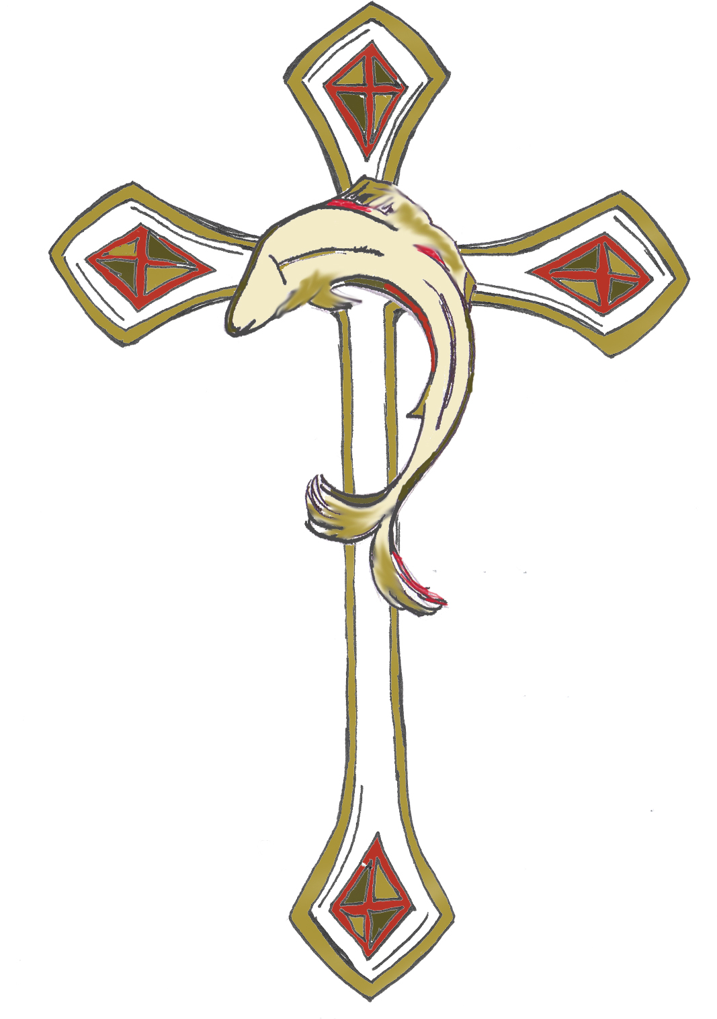

Syresham APVM – Minutes 12/5/24

Present: Alice Palmer. Brenda Faragher, Kathleen Brunning, Sue Palmer, Margaret Miller, Nicola Billingham, David Billingham, Mike Yallop, David Wright, Irene Wright, Mary Braybrook, Rev Hugh White plus Angie Yallop &Tandy – not on ERoll.

Apologies : none received

Minutes & Matters Arising
Minutes for the two Vestry Meetings held in 2023 were agreed. There were no matters arising.

Elections

Church Warden – no nominations – vacant
Church Representatives on the BPCC Alice Palmer tenure ends in 2025
No nominations for a second representative
Deanery Synod Representatives No nominations – Rev Hugh encouraged people to think about joining.
SCC lay members – Sallie Connery, Margaret Miller, David Wright, Brenda Faragher & Kathleen Brunning tenure ends 2025 – no resignations
David Billingham elected for a three year tenure.
Alice Palmer - member as Representative.

Trustees were all re-elected:
Madge Payne - Brian Miller, Sallie Connery, Kathleen Brunning with Alice Palmer as BPCC Representative and Rev Hugh White as Rector
Hammond - Sallie Connery, David Wright, Alice Palmer & Rev Hugh White as Rector

Electoral Roll Officer – David Billingham continues. No additions to Electoral Roll this year. Next year the Electoral Roll will be completely re written

AOB - Rev Hugh thanked Alice

The meeting ended with the grace.

Date of next meeting TBA April/May 2025

NB outside meeting Brenda will approach Nick Towers to act as auditor again.

